| **Payment** | | | |
| --- | --- | --- | --- |
| **ID** | **Full Payment** | **Installment** | **Total Payment** |
| 1112 | False | True | 107 |
| 1113 | False | False | 160 |
| 1114 | False | True | 160 |
| 1115 | False | True | 107 |
| 1116 | False | True | 160 |
| 1117 | False | True | 160 |
| 1118 | False | True | 160 |
| 1119 | False | True | 160 |
| 1120 | True | False | 160 |
| 1121 | False | True | 54 |
| 1122 | False | True | 220 |
| 1123 | True | False | 220 |
| 1124 | False | True | 220 |
| 1125 | False | True | 147 |
| 1126 | False | True | 220 |
| 1127 | False | True | 220 |
| 1128 | True | False | 220 |
| 1129 | False | True | 220 |
| 1130 | False | True | 74 |
| 1131 | False | True | 220 |
| 1132 | True | False | 220 |
| 1133 | False | True | 220 |
| 1134 | False | True | 280 |
| 1135 | False | True | 280 |
| 1136 | False | True | 187 |
| 1137 | True | False | 280 |
| 1138 | False | True | 280 |
| 1139 | False | True | 280 |
| 1140 | False | True | 187 |
| 1141 | False | True | 280 |
| 1142 | False | True | 280 |
| 1143 | False | True | 280 |
| 1144 | True | False | 280 |
| 1145 | True | False | 280 |
| 1146 | False | True | 280 |
| 1147 | False | True | 117 |
| 1148 | False | True | 350 |
| 1149 | False | True | 350 |
| 1150 | False | True | 350 |
| 1151 | False | True | 233 |
| 1152 | True | False | 350 |
| 1153 | False | True | 350 |
| 1154 | False | True | 350 |
| 1155 | False | True | 350 |
| 1156 | True | False | 350 |
| 1157 | True | False | 350 |
| 1158 | False | True | 350 |
| 1159 | True | False | 425 |
| 1160 | False | True | 425 |
| 1161 | False | True | 142 |
| 1162 | False | True | 425 |
| 1167 | False | True | 425 |
| 1168 | False | True | 283 |
| 1169 | False | True | 425 |
| 1170 | True | False | 425 |
| 1171 | False | True | 425 |
| 1172 | True | False | 425 |
| 1173 | True | False | 425 |
| 1174 | False | True | 425 |

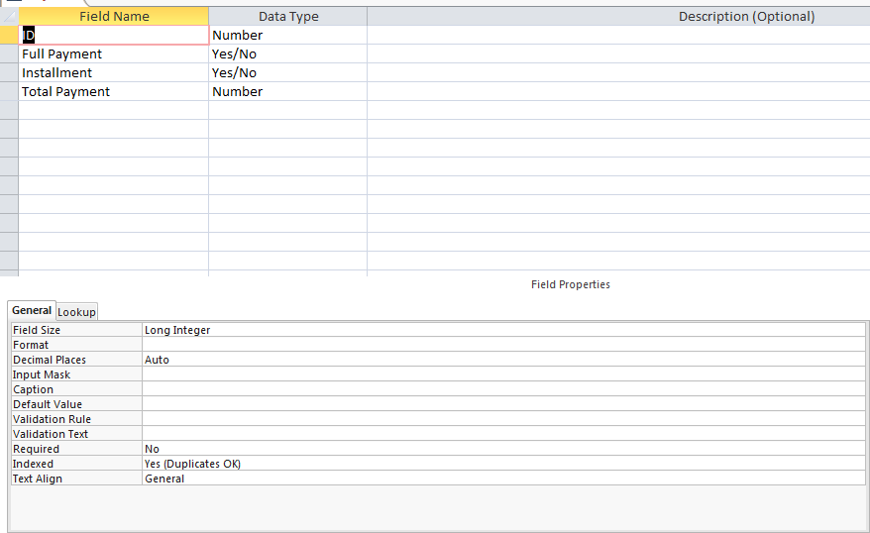

| **Personal** | | | | | | | |
| --- | --- | --- | --- | --- | --- | --- | --- |
| **ID** | **First Name** | **Last Name** | **Address** | **Sex** | **Age** | **Size** | **Telephone Contact** |
| 1112 | Ben | Thomas | 6 Bengal Ctyne | Male | 20 | 5 | 6954154 |
| 1113 | Camel | Boyce | 1 Durey La Cvill | Female | 21 | 4 | 2566416 |
| 1114 | Delon | Phillips | 80 Laluni St | Male | 25 | 6 | 6356555 |
| 1115 | Denise | Miller | 402 Block X Diamond | Female | 27 | 5 | 3326456 |
| 1116 | Evanka | Kellman | 2 Levans St | Female | 31 | 5 | 2356444 |
| 1117 | Felix | Matthews | 59 Zahora | Male | 22 | 8 | 6451545 |
| 1118 | Hilon | Carter | 3 Public Road Subvl | Female | 21 | 8 | 6821546 |
| 1119 | Lindsay | Lowe | 312 East Street | Female | 25 | 2 | 2654645 |
| 1120 | Carmel | York | 101 West Ruimveldt | Female | 26 | 3 | 2654484 |
| 1121 | Raydon | Grant | 5679 Michagin Lorne | Male | 21 | 2 | 6566741 |
| 1122 | Michael | Dante | 87 Junt St | Male | 29 | 4 | 6565649 |
| 1123 | Elizabeth | Koyle | 78 Penny Lane | Female | 24 | 2 | 2235656 |
| 1124 | Jermaine | Haley | 24 Apple St | Male | 23 | 3 | 2659459 |
| 1125 | Dennis | Dojoy | Y4 Yuyr Dam | Male | 25 | 3 | 6554154 |
| 1126 | Kevin | Ramson | 56 Cummingsburg | Male | 21 | 5 | 6594484 |
| 1127 | Sasha | Friten | 17 Helena Dam | Female | 30 | 4 | 2626451 |
| 1128 | Jemima | London | 321 Pardoville | Female | 19 | 5 | 6526546 |
| 1129 | Joshua | Dbest | 31 Dehli st | Male | 21 | 2 | 6676565 |
| 1130 | Shaunsey | Ghent | 43 Gordon St | Female | 17 | 2 | 2652863 |
| 1131 | Kyle | Lyken | 7 Sussex St | Male | 16 | 4 | 2136989 |
| 1132 | Jamacy | Lony | 4 C Tree | Female | 21 | 4 | 6386865 |
| 1133 | Mariah | Crane | 152 Fifth St | Female | 29 | 2 | 2145899 |
| 1134 | Adrian | Alli | 140 Crown St | Male | 22 | 3 | 2598446 |
| 1135 | Akeel | Griffith | 24 Liverpool St | Male | 23 | 1 | 2595549 |
| 1136 | Akeim | Bailey | 77 Pinceton St | Male | 20 | 3 | 6589235 |
| 1137 | Asanti | Phillips | 49 Pike St | Female | 30 | 2 | 2155585 |
| 1138 | Charles | Ramson | 49 1st Alley | Male | 27 | 5 | 2896665 |
| 1139 | Christopher | Chan | 44 Joseph Award | Male | 18 | 2 | 2165863 |
| 1140 | Clivannd | Walters | 77 Robb St | Female | 22 | 3 | 6465986 |
| 1141 | Gordon | Phillips | 32 Nabaclis | Male | 21 | 6 | 6599848 |
| 1142 | Hackim | Chase | 292 West Ruimveldt | Male | 17 | 5 | 8787887 |
| 1143 | Laleta | Ramroop | 889 Section A Diamond | Female | 16 | 2 | 6578947 |
| 1144 | Lilian | Morgan | 2 Prince William St | Female | 28 | 2 | 5648974 |
| 1145 | Ronell | Matthews | 173 Bighton St | Male | 23 | 1 | 5485418 |
| 1146 | Vanessa | Horthon | 1o I Victor St | Female | 20 | 3 | 6547897 |
| 1147 | Carlos | LaRose | 908 Kellam Village | Male | 28 | 6 | 6597979 |
| 1148 | Ion | Ghent | 87 Tyre St | Male | 20 | 2 | 6797987 |
| 1149 | Jason | Sookdeo | Block V 56 Diamond | Male | 27 | 6 | 2984789 |
| 1150 | June | Bugg | 34 Hone St | Female | 22 | 2 | 2378787 |
| 1151 | Katherina | Ping | 098 Longe St | Female | 26 | 1 | 2563456 |
| 1152 | Luey | Thompson | 34 Yarrow Dam | Male | 25 | 2 | 7687234 |
| 1153 | Sheneka | Ghent | 1378 Yunickk Mile St | Female | 24 | 3 | 6679585 |
| 1154 | Troy | Tilley | 123 Shell Road 225 Thomas St | Male | 29 | 3 | 2334455 |
| 1155 | Vanessa | Munroe | 4 Easter Dam | Female | 24 | 5 | 4564567 |
| 1156 | Ariane | Dillian | 72 Greenhearts St | Female | 26 | 2 | 6798943 |
| 1157 | Renesmay | Jack | 1212 Lol Juice Dam | Female | 22 | 5 | 5677865 |
| 1158 | Reana | Orlando | 56 Aubrey Barker St | Female | 21 | 3 | 6547656 |
| 1159 | Shondel | Ghent | 65 Treegs St | Female | 20 | 5 | 7807562 |
| 1160 | Chris | Harris | 5 Gill Dam | Male | 19 | 4 | 6700775 |
| 1161 | Stephanie | Simon | 98 Jonestown | Female | 16 | 4 | 6598709 |
| 1162 | Mikali | Justice | 98 Deigo St | Male | 20 | 6 | 8037876 |
| 1167 | John | Mark | 88 Imperial Beach | Male | 22 | 5 | 9868978 |
| 1168 | Hailey | Bentick | 6 Kenyan St | Female | 27 | 6 | 4698707 |
| 1169 | Darren | Calistro | 78 North Valley | Male | 20 | 2 | 7867484 |
| 1170 | Stephen | Pollard | 6 Tea St | Male | 32 | 4 | 4799969 |
| 1171 | Lonsdale | Reese | 99 Illinois | Male | 31 | 2 | 7687634 |
| 1172 | Terrence | Trent | 6 Yearton | Male | 33 | 1 | 6789578 |
| 1173 | Joyann | Jilop | 76 Apple Bottom St | Female | 21 | 5 | 2314556 |
| 1174 | Cassieann | Norton | 132 Danrade St | Female | 23 | 6 | 6576758 |

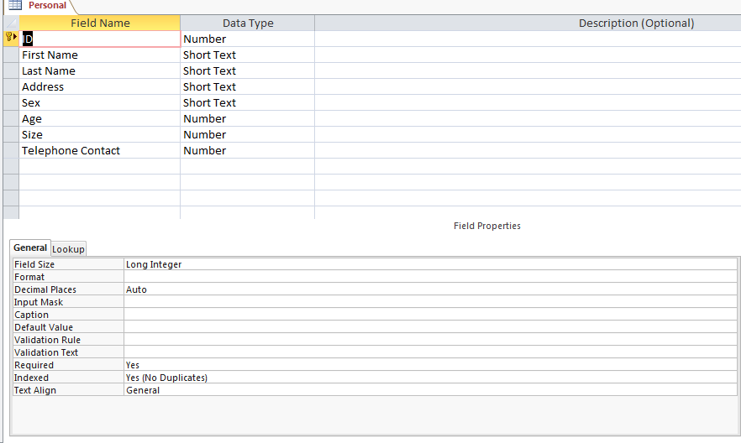

| **Section** | |
| --- | --- |
| **ID** | **Section** |
| 1112 | 1 |
| 1113 | 1 |
| 1114 | 1 |
| 1115 | 1 |
| 1116 | 1 |
| 1117 | 1 |
| 1118 | 1 |
| 1119 | 1 |
| 1120 | 1 |
| 1121 | 1 |
| 1122 | 2 |
| 1123 | 2 |
| 1124 | 2 |
| 1125 | 2 |
| 1126 | 2 |
| 1127 | 2 |
| 1128 | 2 |
| 1129 | 2 |
| 1130 | 2 |
| 1131 | 2 |
| 1132 | 2 |
| 1133 | 2 |
| 1134 | 3 |
| 1135 | 3 |
| 1136 | 3 |
| 1137 | 3 |
| 1138 | 3 |
| 1139 | 3 |
| 1140 | 3 |
| 1141 | 3 |
| 1142 | 3 |
| 1143 | 3 |
| 1144 | 3 |
| 1145 | 3 |
| 1146 | 3 |
| 1147 | 4 |
| 1148 | 4 |
| 1149 | 4 |
| 1150 | 4 |
| 1151 | 4 |
| 1152 | 4 |
| 1153 | 4 |
| 1154 | 4 |
| 1155 | 4 |
| 1156 | 4 |
| 1157 | 4 |
| 1158 | 4 |
| 1159 | 5 |
| 1160 | 5 |
| 1161 | 5 |
| 1162 | 5 |
| 1167 | 5 |
| 1168 | 5 |
| 1169 | 5 |
| 1170 | 5 |
| 1171 | 5 |
| 1172 | 5 |
| 1173 | 5 |
| 1174 | 5 |

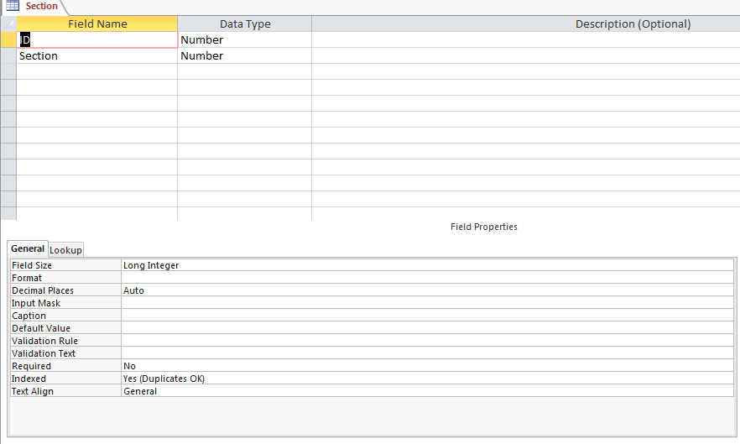

| **FULL PAY** | | | | | |
| --- | --- | --- | --- | --- | --- |
| **ID** | **First Name** | **Last Name** | **Full Payment** | **Section** | **Total Payment** |
| 1120 | Carmel | York | True | 1 | 160 |
| 1123 | Elizabeth | Koyle | True | 2 | 220 |
| 1128 | Jemima | London | True | 2 | 220 |
| 1132 | Jamacy | Lony | True | 2 | 220 |
| 1137 | Asanti | Phillips | True | 3 | 280 |
| 1144 | Lilian | Morgan | True | 3 | 280 |
| 1145 | Ronell | Matthews | True | 3 | 280 |
| 1152 | Luey | Thompson | True | 4 | 350 |
| 1156 | Ariane | Dillian | True | 4 | 350 |
| 1157 | Renesmay | Jack | True | 4 | 350 |
| 1159 | Shondel | Ghent | True | 5 | 425 |
| 1170 | Stephen | Pollard | True | 5 | 425 |
| 1172 | Terrence | Trent | True | 5 | 425 |
| 1173 | Joyann | Jilop | True | 5 | 425 |

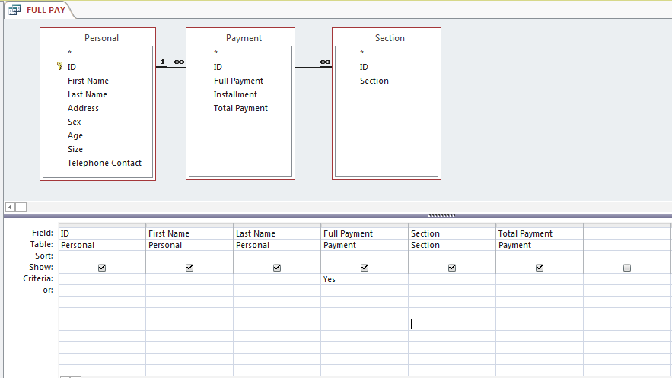

| **Gift Voucher** | | | | | |
| --- | --- | --- | --- | --- | --- |
| **ID** | **First Name** | **Last Name** | **Sex** | **Total Payment** | **GiftVoucher** |
| 1113 | Camel | Boyce | Female | 160 | 19.2 |
| 1115 | Denise | Miller | Female | 107 | 12.84 |
| 1116 | Evanka | Kellman | Female | 160 | 19.2 |
| 1118 | Hilon | Carter | Female | 160 | 19.2 |
| 1119 | Lindsay | Lowe | Female | 160 | 19.2 |
| 1120 | Carmel | York | Female | 160 | 19.2 |
| 1123 | Elizabeth | Koyle | Female | 220 | 26.4 |
| 1127 | Sasha | Friten | Female | 220 | 26.4 |
| 1128 | Jemima | London | Female | 220 | 26.4 |
| 1130 | Shaunsey | Ghent | Female | 74 | 8.88 |
| 1132 | Jamacy | Lony | Female | 220 | 26.4 |
| 1133 | Mariah | Crane | Female | 220 | 26.4 |
| 1137 | Asanti | Phillips | Female | 280 | 33.6 |
| 1140 | Clivannd | Walters | Female | 187 | 22.44 |
| 1143 | Laleta | Ramroop | Female | 280 | 33.6 |
| 1144 | Lilian | Morgan | Female | 280 | 33.6 |
| 1146 | Vanessa | Horthon | Female | 280 | 33.6 |
| 1150 | June | Bugg | Female | 350 | 42 |
| 1151 | Katherina | Ping | Female | 233 | 27.96 |
| 1153 | Sheneka | Ghent | Female | 350 | 42 |
| 1155 | Vanessa | Munroe | Female | 350 | 42 |
| 1156 | Ariane | Dillian | Female | 350 | 42 |
| 1157 | Renesmay | Jack | Female | 350 | 42 |
| 1158 | Reana | Orlando | Female | 350 | 42 |
| 1159 | Shondel | Ghent | Female | 425 | 51 |
| 1161 | Stephanie | Simon | Female | 142 | 17.04 |
| 1168 | Hailey | Bentick | Female | 283 | 33.96 |
| 1173 | Joyann | Jilop | Female | 425 | 51 |
| 1174 | Cassieann | Norton | Female | 425 | 51 |

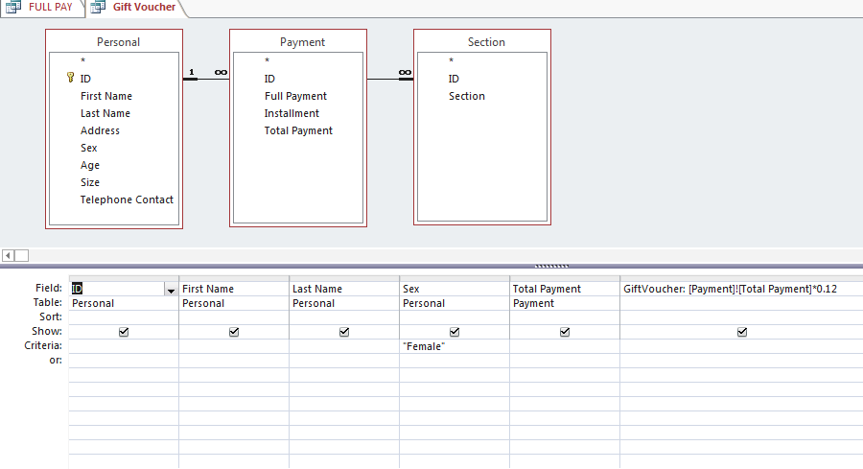

| **Paidup** | | | |
| --- | --- | --- | --- |
| **ID** | **Last Name** | **Section** | **Total Payment** |
| 1120 | York | 1 | 160 |
| 1112 | Thomas | 1 | 107 |
| 1114 | Phillips | 1 | 160 |
| 1115 | Miller | 1 | 107 |
| 1117 | Matthews | 1 | 160 |
| 1119 | Lowe | 1 | 160 |
| 1116 | Kellman | 1 | 160 |
| 1121 | Grant | 1 | 54 |
| 1118 | Carter | 1 | 160 |
| 1113 | Boyce | 1 | 160 |

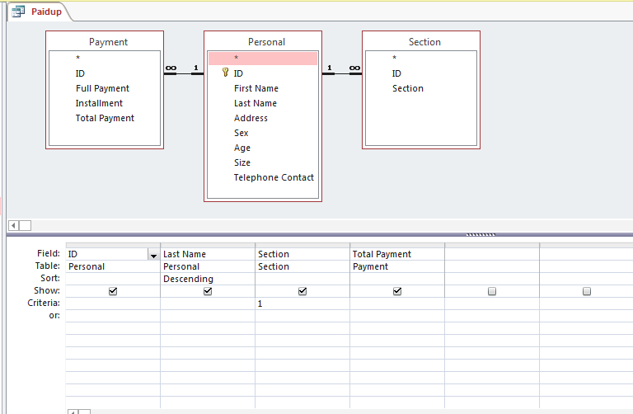

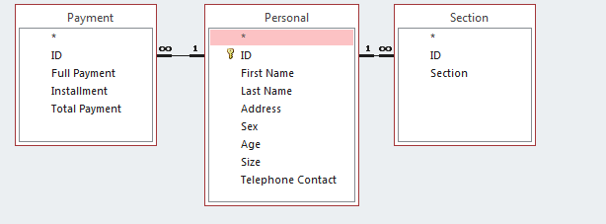

| **personal data** | | | | | |
| --- | --- | --- | --- | --- | --- |
| **First Name** | **Last Name** | **Age** | **Size** | **Address** | **Telephone Contact** |
| Ben | Thomas | 20 | 5 | 6 Bengal Ctyne | 6954154 |
| Camel | Boyce | 21 | 4 | 1 Durey La Cvill | 2566416 |
| Delon | Phillips | 25 | 6 | 80 Laluni St | 6356555 |
| Denise | Miller | 27 | 5 | 402 Block X Diamond | 3326456 |
| Evanka | Kellman | 31 | 5 | 2 Levans St | 2356444 |
| Felix | Matthews | 22 | 8 | 59 Zahora | 6451545 |
| Hilon | Carter | 21 | 8 | 3 Public Road Subvl | 6821546 |
| Lindsay | Lowe | 25 | 2 | 312 East Street | 2654645 |
| Carmel | York | 26 | 3 | 101 West Ruimveldt | 2654484 |
| Raydon | Grant | 21 | 2 | 5679 Michagin Lorne | 6566741 |
| Michael | Dante | 29 | 4 | 87 Junt St | 6565649 |
| Elizabeth | Koyle | 24 | 2 | 78 Penny Lane | 2235656 |
| Jermaine | Haley | 23 | 3 | 24 Apple St | 2659459 |
| Dennis | Dojoy | 25 | 3 | Y4 Yuyr Dam | 6554154 |
| Kevin | Ramson | 21 | 5 | 56 Cummingsburg | 6594484 |
| Sasha | Friten | 30 | 4 | 17 Helena Dam | 2626451 |
| Jemima | London | 19 | 5 | 321 Pardoville | 6526546 |
| Joshua | Dbest | 21 | 2 | 31 Dehli st | 6676565 |
| Shaunsey | Ghent | 17 | 2 | 43 Gordon St | 2652863 |
| Kyle | Lyken | 16 | 4 | 7 Sussex St | 2136989 |
| Jamacy | Lony | 21 | 4 | 4 C Tree | 6386865 |
| Mariah | Crane | 29 | 2 | 152 Fifth St | 2145899 |
| Adrian | Alli | 22 | 3 | 140 Crown St | 2598446 |
| Akeel | Griffith | 23 | 1 | 24 Liverpool St | 2595549 |
| Akeim | Bailey | 20 | 3 | 77 Pinceton St | 6589235 |
| Asanti | Phillips | 30 | 2 | 49 Pike St | 2155585 |
| Charles | Ramson | 27 | 5 | 49 1st Alley | 2896665 |
| Christopher | Chan | 18 | 2 | 44 Joseph Award | 2165863 |
| Clivannd | Walters | 22 | 3 | 77 Robb St | 6465986 |
| Gordon | Phillips | 21 | 6 | 32 Nabaclis | 6599848 |
| Hackim | Chase | 17 | 5 | 292 West Ruimveldt | 8787887 |
| Laleta | Ramroop | 16 | 2 | 889 Section A Diamond | 6578947 |
| Lilian | Morgan | 28 | 2 | 2 Prince William St | 5648974 |
| Ronell | Matthews | 23 | 1 | 173 Bighton St | 5485418 |
| Vanessa | Horthon | 20 | 3 | 1o I Victor St | 6547897 |
| Carlos | LaRose | 28 | 6 | 908 Kellam Village | 6597979 |
| Ion | Ghent | 20 | 2 | 87 Tyre St | 6797987 |
| Jason | Sookdeo | 27 | 6 | Block V 56 Diamond | 2984789 |
| June | Bugg | 22 | 2 | 34 Hone St | 2378787 |
| Katherina | Ping | 26 | 1 | 098 Longe St | 2563456 |
| Luey | Thompson | 25 | 2 | 34 Yarrow Dam | 7687234 |
| Sheneka | Ghent | 24 | 3 | 1378 Yunickk Mile St | 6679585 |
| Troy | Tilley | 29 | 3 | 123 Shell Road 225 Thomas St | 2334455 |
| Vanessa | Munroe | 24 | 5 | 4 Easter Dam | 4564567 |
| Ariane | Dillian | 26 | 2 | 72 Greenhearts St | 6798943 |
| Renesmay | Jack | 22 | 5 | 1212 Lol Juice Dam | 5677865 |
| Reana | Orlando | 21 | 3 | 56 Aubrey Barker St | 6547656 |
| Shondel | Ghent | 20 | 5 | 65 Treegs St | 7807562 |
| Chris | Harris | 19 | 4 | 5 Gill Dam | 6700775 |
| Stephanie | Simon | 16 | 4 | 98 Jonestown | 6598709 |
| Mikali | Justice | 20 | 6 | 98 Deigo St | 8037876 |
| John | Mark | 22 | 5 | 88 Imperial Beach | 9868978 |
| Hailey | Bentick | 27 | 6 | 6 Kenyan St | 4698707 |
| Darren | Calistro | 20 | 2 | 78 North Valley | 7867484 |
| Stephen | Pollard | 32 | 4 | 6 Tea St | 4799969 |
| Lonsdale | Reese | 31 | 2 | 99 Illinois | 7687634 |
| Terrence | Trent | 33 | 1 | 6 Yearton | 6789578 |
| Joyann | Jilop | 21 | 5 | 76 Apple Bottom St | 2314556 |
| Cassieann | Norton | 23 | 6 | 132 Danrade St | 6576758 |

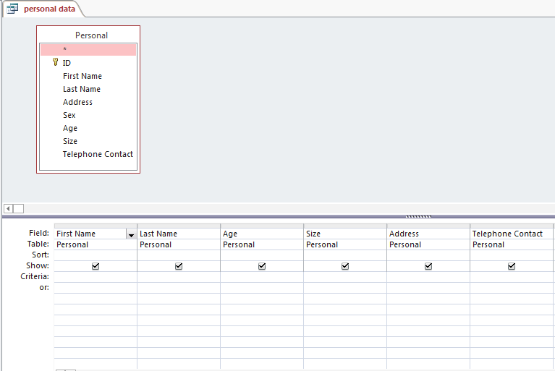

| **Rebate** | | | | | | |
| --- | --- | --- | --- | --- | --- | --- |
| **ID** | **First Name** | **Last Name** | **Address** | **Total Payment** | **Section** | **Rebate** |
| 1112 | Ben | Thomas | 6 Bengal Ctyne | 107 | 1 | $16.05 |
| 1113 | Camel | Boyce | 1 Durey La Cvill | 160 | 1 | $24.00 |
| 1114 | Delon | Phillips | 80 Laluni St | 160 | 1 | $24.00 |
| 1115 | Denise | Miller | 402 Block X Diamond | 107 | 1 | $16.05 |
| 1116 | Evanka | Kellman | 2 Levans St | 160 | 1 | $24.00 |
| 1117 | Felix | Matthews | 59 Zahora | 160 | 1 | $24.00 |
| 1118 | Hilon | Carter | 3 Public Road Subvl | 160 | 1 | $24.00 |
| 1119 | Lindsay | Lowe | 312 East Street | 160 | 1 | $24.00 |
| 1120 | Carmel | York | 101 West Ruimveldt | 160 | 1 | $24.00 |
| 1121 | Raydon | Grant | 5679 Michagin Lorne | 54 | 1 | $8.10 |
| 1122 | Michael | Dante | 87 Junt St | 220 | 2 | $33.00 |
| 1123 | Elizabeth | Koyle | 78 Penny Lane | 220 | 2 | $33.00 |
| 1124 | Jermaine | Haley | 24 Apple St | 220 | 2 | $33.00 |
| 1125 | Dennis | Dojoy | Y4 Yuyr Dam | 147 | 2 | $22.05 |
| 1126 | Kevin | Ramson | 56 Cummingsburg | 220 | 2 | $33.00 |
| 1127 | Sasha | Friten | 17 Helena Dam | 220 | 2 | $33.00 |
| 1128 | Jemima | London | 321 Pardoville | 220 | 2 | $33.00 |
| 1129 | Joshua | Dbest | 31 Dehli st | 220 | 2 | $33.00 |
| 1130 | Shaunsey | Ghent | 43 Gordon St | 74 | 2 | $11.10 |
| 1131 | Kyle | Lyken | 7 Sussex St | 220 | 2 | $33.00 |
| 1132 | Jamacy | Lony | 4 C Tree | 220 | 2 | $33.00 |
| 1133 | Mariah | Crane | 152 Fifth St | 220 | 2 | $33.00 |
| 1134 | Adrian | Alli | 140 Crown St | 280 | 3 | $42.00 |
| 1135 | Akeel | Griffith | 24 Liverpool St | 280 | 3 | $42.00 |
| 1136 | Akeim | Bailey | 77 Pinceton St | 187 | 3 | $28.05 |
| 1137 | Asanti | Phillips | 49 Pike St | 280 | 3 | $42.00 |
| 1138 | Charles | Ramson | 49 1st Alley | 280 | 3 | $42.00 |
| 1139 | Christopher | Chan | 44 Joseph Award | 280 | 3 | $42.00 |
| 1140 | Clivannd | Walters | 77 Robb St | 187 | 3 | $28.05 |
| 1141 | Gordon | Phillips | 32 Nabaclis | 280 | 3 | $42.00 |
| 1142 | Hackim | Chase | 292 West Ruimveldt | 280 | 3 | $42.00 |
| 1143 | Laleta | Ramroop | 889 Section A Diamond | 280 | 3 | $42.00 |
| 1144 | Lilian | Morgan | 2 Prince William St | 280 | 3 | $42.00 |
| 1145 | Ronell | Matthews | 173 Bighton St | 280 | 3 | $42.00 |
| 1146 | Vanessa | Horthon | 1o I Victor St | 280 | 3 | $42.00 |
| 1147 | Carlos | LaRose | 908 Kellam Village | 117 | 4 | $17.55 |
| 1148 | Ion | Ghent | 87 Tyre St | 350 | 4 | $52.50 |
| 1149 | Jason | Sookdeo | Block V 56 Diamond | 350 | 4 | $52.50 |
| 1150 | June | Bugg | 34 Hone St | 350 | 4 | $52.50 |
| 1151 | Katherina | Ping | 098 Longe St | 233 | 4 | $34.95 |
| 1152 | Luey | Thompson | 34 Yarrow Dam | 350 | 4 | $52.50 |
| 1153 | Sheneka | Ghent | 1378 Yunickk Mile St | 350 | 4 | $52.50 |
| 1154 | Troy | Tilley | 123 Shell Road 225 Thomas St | 350 | 4 | $52.50 |
| 1155 | Vanessa | Munroe | 4 Easter Dam | 350 | 4 | $52.50 |
| 1156 | Ariane | Dillian | 72 Greenhearts St | 350 | 4 | $52.50 |
| 1157 | Renesmay | Jack | 1212 Lol Juice Dam | 350 | 4 | $52.50 |
| 1158 | Reana | Orlando | 56 Aubrey Barker St | 350 | 4 | $52.50 |
| 1159 | Shondel | Ghent | 65 Treegs St | 425 | 5 | $63.75 |
| 1160 | Chris | Harris | 5 Gill Dam | 425 | 5 | $63.75 |
| 1161 | Stephanie | Simon | 98 Jonestown | 142 | 5 | $21.30 |
| 1162 | Mikali | Justice | 98 Deigo St | 425 | 5 | $63.75 |
| 1167 | John | Mark | 88 Imperial Beach | 425 | 5 | $63.75 |
| 1168 | Hailey | Bentick | 6 Kenyan St | 283 | 5 | $42.45 |
| 1169 | Darren | Calistro | 78 North Valley | 425 | 5 | $63.75 |
| 1170 | Stephen | Pollard | 6 Tea St | 425 | 5 | $63.75 |
| 1171 | Lonsdale | Reese | 99 Illinois | 425 | 5 | $63.75 |
| 1172 | Terrence | Trent | 6 Yearton | 425 | 5 | $63.75 |
| 1173 | Joyann | Jilop | 76 Apple Bottom St | 425 | 5 | $63.75 |
| 1174 | Cassieann | Norton | 132 Danrade St | 425 | 5 | $63.75 |

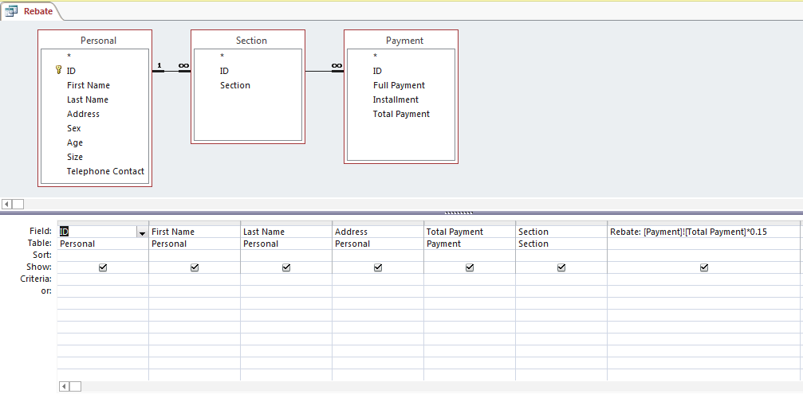

| **TwentiesLadies** | | | | |
| --- | --- | --- | --- | --- |
| **ID** | **First Name** | **Last Name** | **Sex** | **Age** |
| 1113 | Camel | Boyce | Female | 21 |
| 1115 | Denise | Miller | Female | 27 |
| 1118 | Hilon | Carter | Female | 21 |
| 1119 | Lindsay | Lowe | Female | 25 |
| 1120 | Carmel | York | Female | 26 |
| 1123 | Elizabeth | Koyle | Female | 24 |
| 1127 | Sasha | Friten | Female | 30 |
| 1132 | Jamacy | Lony | Female | 21 |
| 1133 | Mariah | Crane | Female | 29 |
| 1137 | Asanti | Phillips | Female | 30 |
| 1140 | Clivannd | Walters | Female | 22 |
| 1144 | Lilian | Morgan | Female | 28 |
| 1146 | Vanessa | Horthon | Female | 20 |
| 1150 | June | Bugg | Female | 22 |
| 1151 | Katherina | Ping | Female | 26 |
| 1153 | Sheneka | Ghent | Female | 24 |
| 1155 | Vanessa | Munroe | Female | 24 |
| 1156 | Ariane | Dillian | Female | 26 |
| 1157 | Renesmay | Jack | Female | 22 |
| 1158 | Reana | Orlando | Female | 21 |
| 1159 | Shondel | Ghent | Female | 20 |
| 1168 | Hailey | Bentick | Female | 27 |
| 1173 | Joyann | Jilop | Female | 21 |
| 1174 | Cassieann | Norton | Female | 23 |